32img 32img**Widening or Automatic Type Conversion**

Widening conversion takes place when two data types are automatically converted. This happens when:

* The two data types are compatible.
* When we assign a value of a smaller data type to a bigger data type.

For Example, in java, the numeric data types are compatible with each other but no automatic conversion is supported from numeric type to char or boolean. Also, char and boolean are not compatible with each other.



**Example:**

* Java

| // Java Program to Illustrate Automatic Type Conversion    // Main class  **class** TYC {        // Main driver method  **public** **static** **void** main(String[] args)      {  **int** i = 100;            // Automatic type conversion          // Integer to long type  **long** l = i;            // Automatic type conversion          // long to float type  **float** f = l;            // Print and display commands          System.out.println("Int value " + i);          System.out.println("Long value " + l);          System.out.println("Float value " + f);      }  } |
| --- |

**Output**

Int value 100

Long value 100

Float value 100.0

**Narrowing or Explicit Conversion**

If we want to assign a value of a larger data type to a smaller data type we perform explicit type casting or narrowing.

* This is useful for incompatible data types where automatic conversion cannot be done.
* Here, the target type specifies the desired type to convert the specified value to.



char and number are not compatible with each other. Let’s see when we try to convert one into another.

* Java

| // Java program to illustrate Incompatible data Type  // for Explicit Type Conversion    // Main class  **public** **class** TYC {        // Main driver method  **public** **static** **void** main(String[] argv)      {            // Declaring character variable  **char** ch = 'c';          // Declaringinteger variable  **int** num = 88;          // Trying to insert integer to character          ch = num;      }  } |
| --- |

**Output:** An error will be generated

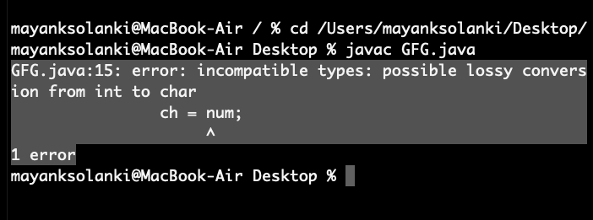

This error is generated as an integer variable takes 4 bytes while character datatype requires 2 bytes. We are trying to plot data from 4 bytes into 2 bytes which is not possible.

**How to do Explicit Conversion?**

* Java

| // Java program to Illustrate Explicit Type Conversion    // Main class  **public** **class** TYC {        // Main driver method  **public** **static** **void** main(String[] args)      {            // Double datatype  **double** d = 100.04;            // Explicit type casting by forcefully getting          // data from long datatype to integer type  **long** l = (**long**)d;            // Explicit type casting  **int** i = (**int**)l;            // Print statements          System.out.println("Double value " + d);            // While printing we will see that          // fractional part lost          System.out.println("Long value " + l);            // While printing we will see that          // fractional part lost          System.out.println("Int value " + i);      }  } |
| --- |

**Output**

Double value 100.04

Long value 100

Int value 100

***Note:****While assigning value to byte type the fractional part is lost and is reduced to modulo 256(range of byte).*

**Example:**

* Java

| // Java Program to Illustrate Conversion of  // Integer and Double to Byte    // Main class  **class** TYC {        // Main driver method  **public** **static** **void** main(String args[])      {          // Declaring byte variable  **byte** b;            // Declaring and initializing integer and double  **int** i = 257;  **double** d = 323.142;            // Display message          System.out.println("Conversion of int to byte.");            // i % 256          b = (**byte**)i;            // Print commands          System.out.println("i = " + i + " b = " + b);          System.out.println(              "\nConversion of double to byte.");            // d % 256          b = (**byte**)d;            // Print commands          System.out.println("d = " + d + " b= " + b);      }  } |
| --- |

**Output**

Conversion of int to byte.

i = 257 b = 1

Conversion of double to byte.

d = 323.142 b= 67

**Type Promotion in Expressions**

While evaluating expressions, the intermediate value may exceed the range of operands and hence the expression value will be promoted. Some conditions for type promotion are:

1. Java automatically promotes each byte, short, or char operand to int when evaluating an expression.
2. If one operand is long, float or double the whole expression is promoted to long, float, or double respectively.

**Example:**

* Java

| // Java program to Illustrate Type promotion in Expressions    // Main class  **class** TYC {        // Main driver method  **public** **static** **void** main(String args[])      {            // Declaring and initializing primitive types  **byte** b = 42;  **char** c = 'a';  **short** s = 1024;  **int** i = 50000;  **float** f = 5.67f;  **double** d = .1234;            // The Expression  **double** result = (f * b) + (i / c) - (d * s);            // Printing the result obtained after          // all the promotions are done          System.out.println("result = " + result);      }  } |
| --- |

**Output**

result = 626.7784146484375

**Explicit Type Casting in Expressions**

While evaluating expressions, the result is automatically updated to a larger data type of the operand. But if we store that result in any smaller data type it generates a compile-time error, due to which we need to typecast the result.

**Example:**

* Java

| // Java program to Illustrate Type Casting  // in Integer to Byte    // Main class  **class** TYC {        // Main driver method  **public** **static** **void** main(String args[])      {            // Declaring byte array  **byte** b = 50;            // Type casting int to byte          b = (**byte**)(b * 2);            // Display value in byte          System.out.println(b);  **byte** bc, be = 50;  // **int** bc;  // bc = be *2;  bc = (**byte**)(be*3);  System.***out***.println("Value of byte data be and bc is : "+ be+ " " + bc);      }  } |
| --- |

**Output**

100

Value of byte data be and bc is : 50 -106

Range of byte is -128 to 127 so bc * 3 = 150 it overflows the byte range, 150-127 =23, -128+22 = -106

***Note:****In case of single operands the result gets converted to int and then it is typecast accordingly, as in the above example.*

Disclaimer: The material is from geeksforgeek website.